**Topic : Descent work and Economic Growth**

|  |  |
| --- | --- |
| **Student Registration Number** | **Name** |
| **IT20642914** | **Gamage B.G.A.C** |
| **IT20641092** | **W.S.S Wijesinha** |
| **IT20637064** | **R.M.C Anuththara** |
| **IT20639662** | **Navodi P.T** |

**Group ID : SEJ006**

**IT20642914 - Gamage B.G.A.C**

|  |
| --- |
| Fail Point/Blocking |
| 1)admin cannot register him self   |
| 2) does not include if logging failed part   |
| 3) Admin should redirect category tab after successful adding |

**before**

After fixing

2nd user flow

User flow 3

**IT20641092- W.S.S Wijesinha**

|  |
| --- |
| **Fail Points /Blocking** |
| 1. Does not include the part of , choosing login roll and login     Diagram  Description automatically generated  Diagram  Description automatically generated  This will allow user to log in as job seeker   1. Does not include validations and Loop   Diagram  Description automatically generated    Diagram  Description automatically generated    user have to re enter details again and again until login details become true   1. User wanted to see jobs in categories so that he/she can find jobs easily   Diagram  Description automatically generated    Diagram  Description automatically generated |

**Before Re-correcting**

**Corrected**

**User flow 1**

**Flow 2**

**IT20637064 - R.M.C Anuththara**

|  |
| --- |
| Fail Point/Blocking |
| 1) Admin can’t register his profile by himself. She/he can log in an existing account. If the login credentials are incorrect she/he will redirect to the login page |
| 2) After the filling post form there should button for submit      3.If an error message displayed then the user will be redirected to Form  BEFORE    AFTER |
| existing flow chart for posting self-employment post    After fixing errors    2nd User Flow    3rd User Flow |

**IT20639662 - Navodi P.T**

Fail Point/Blocking

1)Login issues (Does not include the login validation)

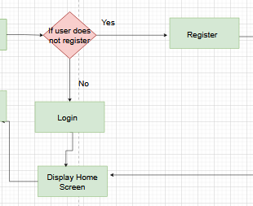

2)Register issue (Does not include the register validation)

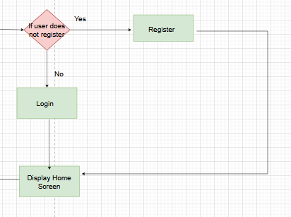

**Before fixing errors**

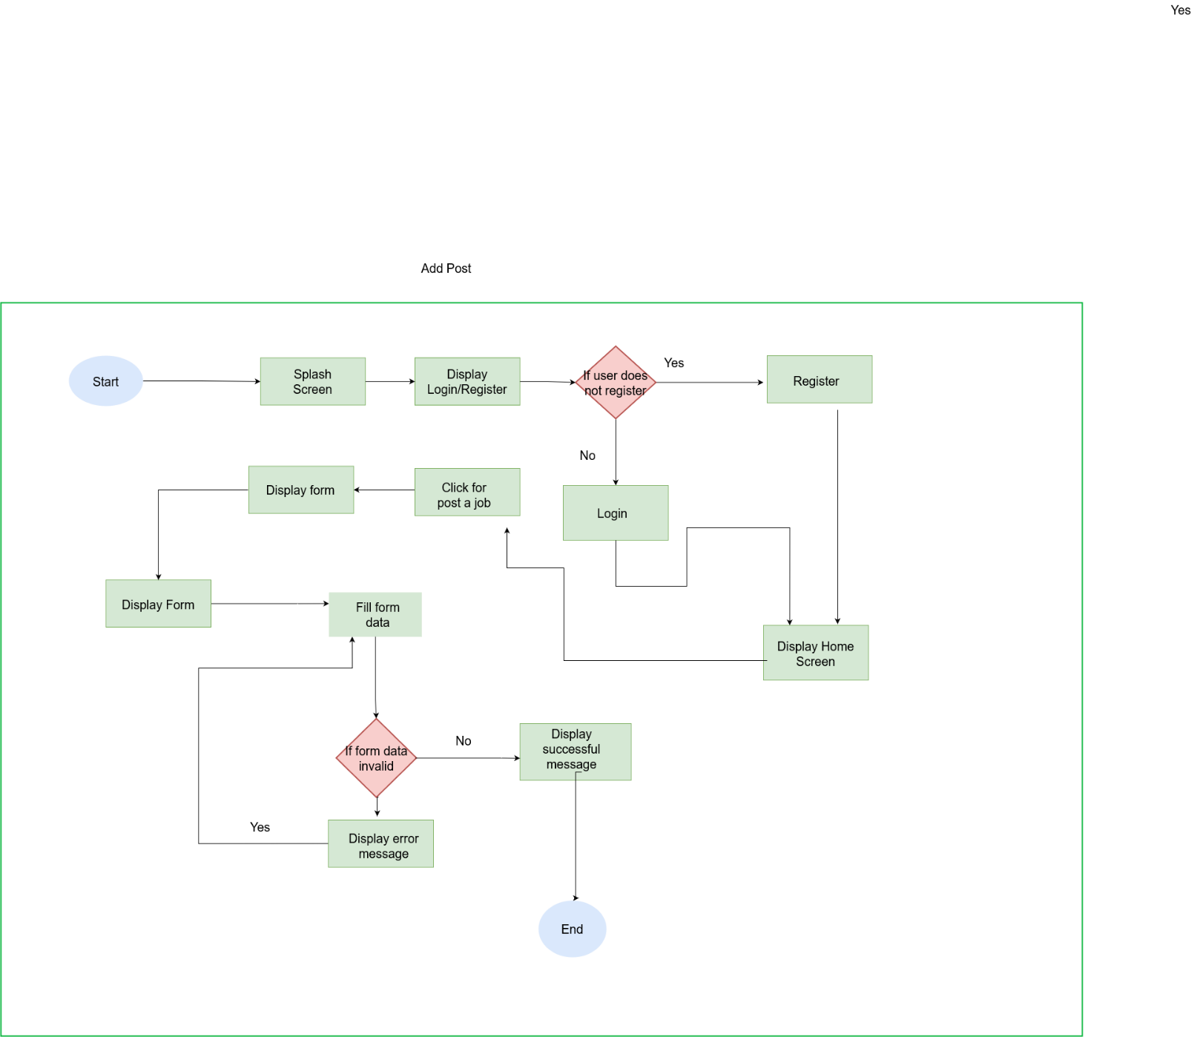

**After fixing errors**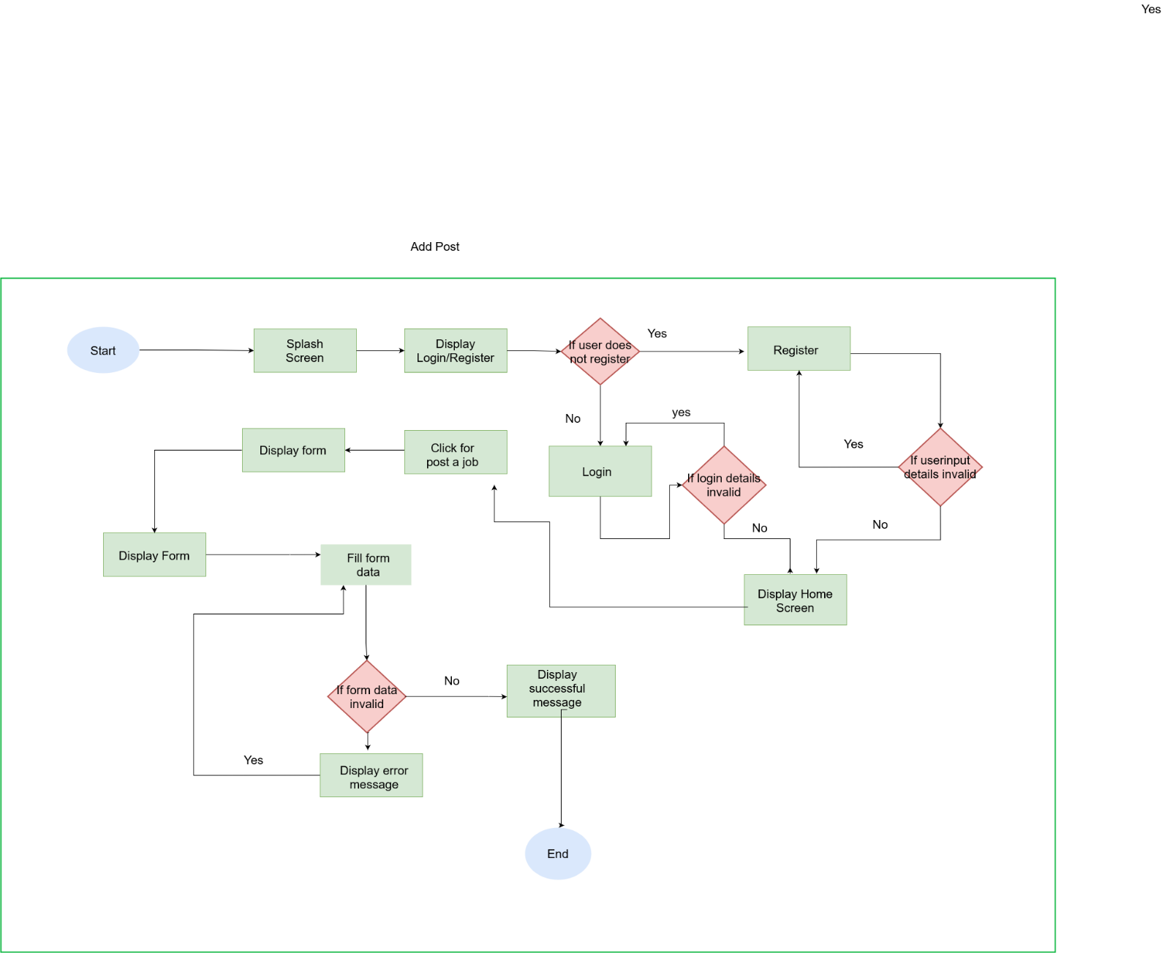

**2nd User flow**- Update post

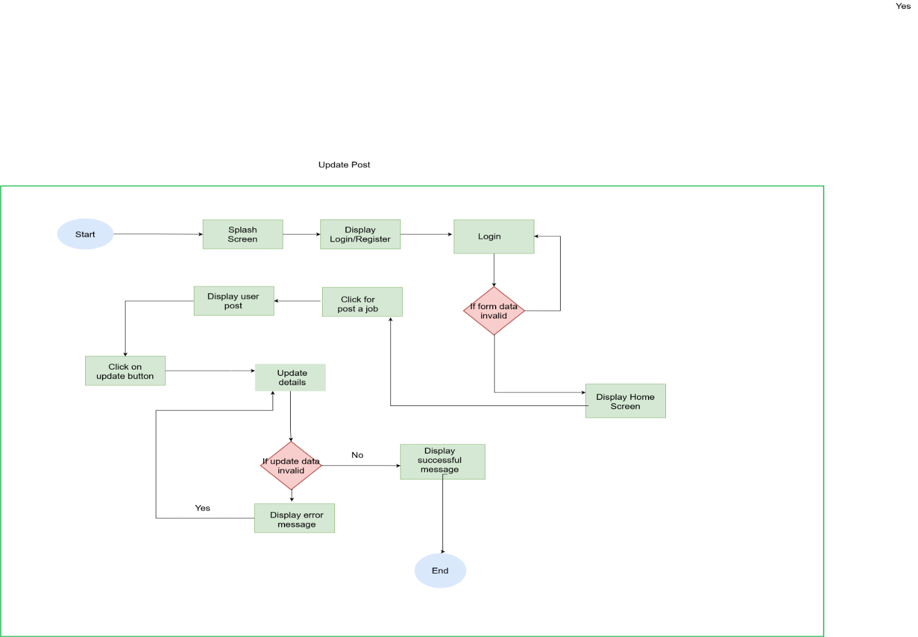

No

Yes

**3rd User flow** – Delete post

